

National University of Computer and Emerging Sciences, Chiniot-Faisalabad Campus

Final Project Report
Object Oriented Programming

Sheeza Shafiq (24F-0794)

- Title:
Chess Game in C++
- Introduction:
Chess is a classical strategy game played on an 8×8 board consisting of 64 cells. Each player controls 16 pieces and aims to checkmate the opponent’s king.
This project focuses on implementing a playable chess game using C++ OOP concepts while modeling the chess environment digitally.
The game is fully functional through keyboard input: users enter moves in standard notation (e.g., “e2 e4”). The system validates moves using programmed rules for each piece and updates the board accordingly, ensuring fair gameplay.
- Project Objectives:
The primary objective of this project is to:
- Implement a functioning chess game using C++
- Demonstrate core OOP pillars: Encapsulation, Inheritance, Polymorphism and Composition
- Correctly enforce chess movement rules
- Detect Check, Checkmate, and Stalemate
- Support special moves (Promotion, Castling, En Passant)
- Game flow
- Game begins from the main menu and initializes all chess pieces in their correct starting positions.
- Players take turns entering moves in chess notation (e.g., e2 e4), starting with White.
- Each move is validated to ensure:
  - Correct piece selection
  - Legal movement rules
  - King safety (no self-check)
- Valid moves update the board with full chess rules including captures, castling, promotion, and en passant.
- After every move, the game checks for check, checkmate, or stalemate.
- Turns alternate until the game ends with either checkmate or stalemate.

- OOP Concepts
Encapsulation
Piece properties protected; access via functions
Inheritance
All pieces extend the base class Piece
Polymorphism
Overridden isValidMove() for each piece type
Abstraction
Game doesn't know internal rules; just asks object
Composition
Board maintains objects of Piece; Game maintains Board

Implementation:
• Accurate rules for each chess piece movement
• Illegal moves blocked with user feedback
• Check & Checkmate detection
• Stalemate draw condition
• Pawn Promotion with user choice
• Castling king/rook repositioning
• En Passant capture logic
• Screen refresh for clean gameplay experience
• Winner announcement after checkmate

  - Output Screenshots
(1)
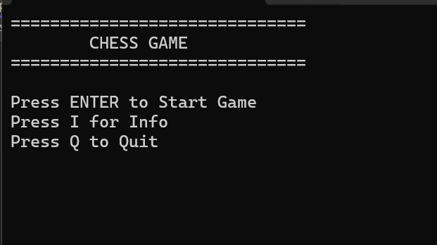
This screen displays the main menu where the user can choose to start the chess game, view game information, or exit the application. It provides the initial user interaction and navigation options.
(2)
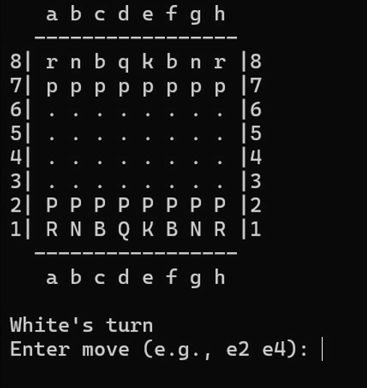
This screen shows the chessboard with all pieces placed in their standard starting positions and prompts the current player to enter a move using chess notation. Gameplay begins here with turns alternating between White and Black.
(3)
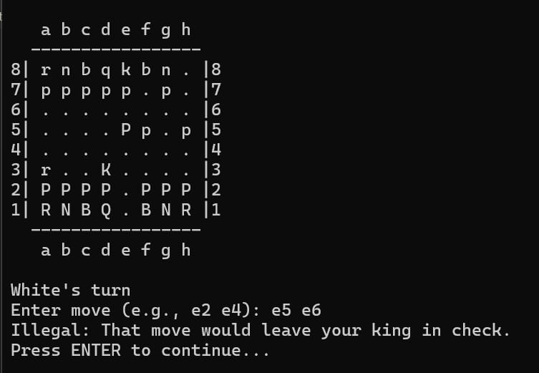
The chessboard shows the current game state with labeled rows/columns, where uppercase letters represent White pieces and lowercase represent Black. The move e5 e6 is rejected because it would leave the player’s king in check, so the program marks it as illegal.
(4)
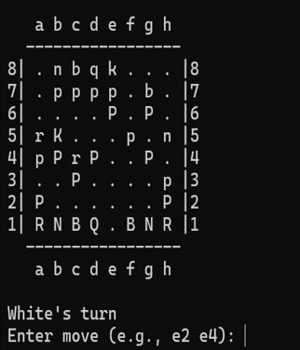
The updated chessboard is displayed after the previous move action, and the console is refreshed for clarity. It is again White’s turn to enter the next move using chess notation.
Conclusion:
This project applies OOP concepts to create a complete and rule-accurate chess game. It uses a modular class structure and implements advanced mechanics such as castling, promotion, and en passant. The development improved understanding of OOP design, logical validation, and game mechanics handling.

